
Lumina Healthcare
SQL Health Operations Analysis
PostgreSQL case study: transforming hospital operational, clinical and financial
data into decision-ready insights.
Presented by Mariam Adetoyi
Data Analyst | Power BI | SQL | Excel | Python
Executive overview
How SQL was used to turn a healthcare database into operational intelligence
BUSINESS NEED
Lumina Healthcare had centralised its data in PostgreSQL but
needed a structured SQL analysis to unlock management
insight.
ANALYTICAL FOCUS
•
Patient demand and admissions
•
Readmissions and recovery outcomes
•
Hospital, department and financial performance
DELIVERABLE
A set of SQL queries, KPIs and interpretation points that help
leadership monitor service utilisation, quality and revenue.
Raw relational data
→
SQL analysis
→
Decisions
Output 1
Operational visibility: admissions,
emergency demand and monthly trends.
Output 2
Quality insight: recovery rates, length of
stay and readmissions.
Output 3
Financial insight: charges, insurance
contribution, patient payments and income.

Business problem
Management needed actionable SQL insight from a relational healthcare database
The database contained patient, clinical, billing and operational data, but the leadership team needed clearer visibility into how hospitals, departments and services were performing.

01 02 03
Measure patient demand: total admissions, emergency Evaluate outcomes: length of stay, recovery rates and 30- Assess finance: total charges, insurance coverage, patient admissions, 2024 activity and admission trends. day readmission patterns. payments and income performance.

Portfolio value
This project demonstrates the ability to translate leadership questions into SQL logic, structure the analysis around measurable KPIs and explain results in a way that supports operational decisions.
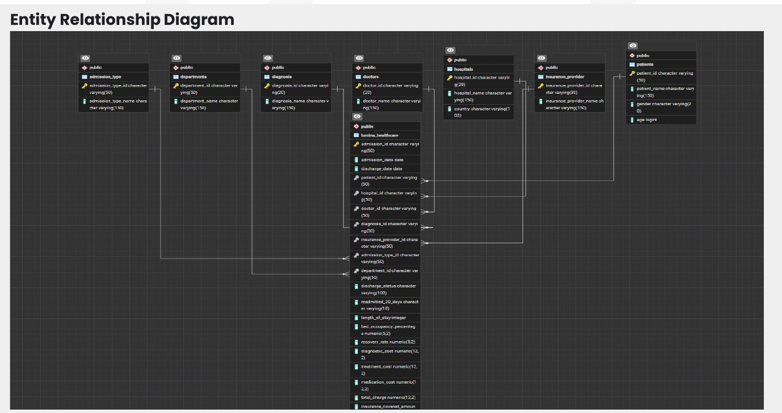
Database structure
Relational tables joined through admission, patient, doctor, hospital and department keys
Core tables used
•
lumina_healthcare as the central fact table
•
patients, hospitals, doctors and departments
•
diagnosis, admission type and insurance provider dimensions
•
Measures: LOS, recovery rate, bed occupancy, charges, patient
paid, outstanding balance and income
Why it matters
A clean relational structure allows admissions to be
analysed by hospital, department, patient group and
financial outcome without losing business context.

SQL analysis workflow
From database exploration to decision-ready findings
2 |  | 3 |  | 4

15
Explore  Review tables and relationships | → | Query  Retrieve records and answer questions | → | Join →  Add hospital, department and patient context | Aggregate  Calculate KPIs and benchmarks | → | Explain  Translate findings into recommendations
The workflow mirrors a practical BI process: understand the data model, write query logic, validate the output and then explain the business meaning.
SQL was used as the analytical layer connecting raw hospital records to KPIs for operations, outcomes and finance.
Analysis area 1: patient demand
Understanding admission volume, emergency demand and utilisation patterns
QUESTIONS ANSWERED
•
How many admissions were recorded overall?
•
How many unique patients were served?
•
What was the volume of emergency admissions?
•
How many admissions occurred in 2024?
•
How did admissions vary by month, year and age group?
SQL LOGIC USED
•
COUNT() for admission and patient volumes
•
WHERE for emergency and 2024 filtering
•
EXTRACT() and TO_CHAR() for date analysis
•
CASE statements for age-group segmentation
•
JOINs to connect patients to admissions
Presentation insight
This section helps management understand service utilisation, pressure points in emergency care and demand patterns that could
support resource planning.

Analysis area 2: outcomes and quality

Using SQL to assess recovery, length of stay and readmission risk

Key KPIs analysed
Average LOS
Assesses inpatient utilisation and care duration.

Recovery rate
Benchmarks clinical outcomes by department.
Readmission rate
Flags potential quality and follow-up issues.

Readmission rate logic
Readmission rate
Readmissions / Total Admissions
This was also analysed by hospital and department using JOINs, GROUP BY and conditional aggregation.

Management value
The analysis helps identify units that may need deeper review, improved discharge planning or targeted operational support.

Analysis area 3: financial performance
Connecting clinical activity to charges, coverage, patient payments and income
KPIS CALCULATED
•
Total healthcare charges
•
Total insurance covered amount
•
Percentage funded by insurance providers
•
Percentage paid by patients
•
Total income by department and hospital
BENCHMARKING LOGIC
•
Departments with revenue above 68.5 million
•
Admissions generating revenue above average
•
Hospitals with total income above the overall average
•
Patients paying more than insurance coverage
Business interpretation
This section helps leadership understand revenue drivers, insurance coverage effectiveness, patient financial burden and high-
performing hospitals or departments.

SQL techniques demonstrated
The project shows practical querying capability across common business-analysis tasks

SELECT / WHERE
Retrieve tables, filter emergency admissions and 2024 activity.

CASE
Segment patients into age groups and calculate conditions.

CAST
Convert values for accurate percentage calculations.

JOINs
Connect admissions to hospitals, departments and patients.

Date functions
EXTRACT and TO_CHAR for admission trends.

Documentation
Queries organised around business questions.

GROUP BY / HAVING
Compare department and hospital performance.

Subqueries
Benchmark revenue, recovery and income against averages.

Relational thinking
Use keys and table grain to maintain context.

Aggregations
COUNT, SUM, AVG and ROUND for KPI calculations.

Conditional aggregation
Calculate readmission volumes and rates.

Insight framing
Translate outputs into decision-focused findings.

Management value delivered
The SQL analysis creates a foundation for leadership reporting, operational monitoring and evidence-based decision-making.
1
Demand planning
Track emergency admissions, annual activity and seasonal trends to inform staffing and
resource allocation.
2
Quality monitoring
Use readmission and recovery patterns to flag hospitals or departments needing deeper
review.
3
Financial oversight
Review high-revenue departments, insurance contribution and patient payment burden.
4
Data maturity
Move from raw relational records to repeatable SQL reporting and KPI-led insight.
This project demonstrates my ability to use SQL not only to query data, but to structure analysis around real business
questions and communicate insight that supports action.

